**Building a Website : Create your first website using Canva**

**Brand Name: SCMV Nail Salon and Spa**

**Category: Beautician**

**Target Audience: Women and Kids**

**Email:** [**scmvnail@gmail.com**](mailto:scmvnail@gmail.com)



**Documentation - With Attached Screenshots for Website Pages**

**Introduction**

Welcome to the documentation for building your first website using Canva. In this guide, we will walk you through the steps to create an attractive and functional website for your brand, SCMV, in the beauty category, catering to women and kids. This document will include a step-by-step walkthrough, screenshots, and tips to help you get started.

**Step 1:**

* Go to the Canva website (https://www.canva.com).
* Sign up for a Canva account using your email address.

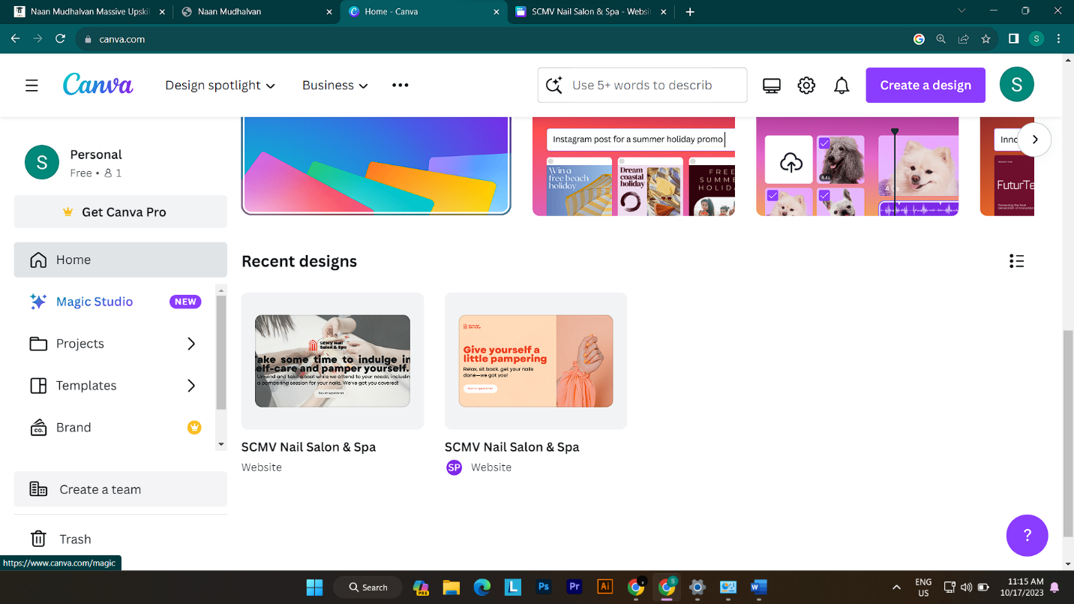

**Step 2: Access Canva's Website Builder**

* Once you're logged in, click on "Create a design" and select "Website."

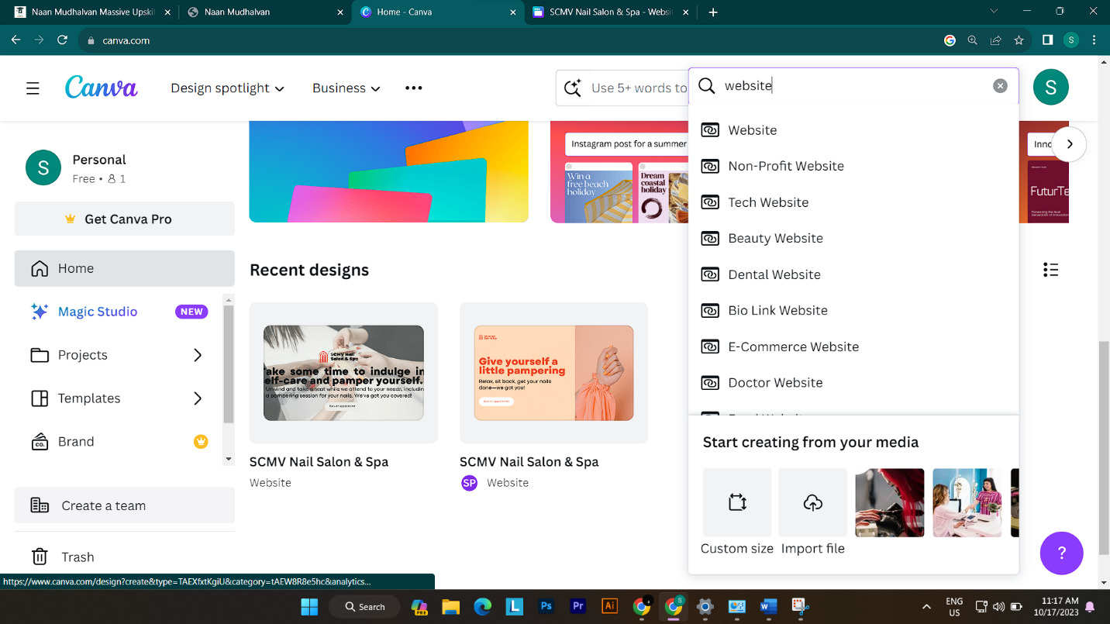

**Step 3: Choose a Template**

* Browse through Canva's collection of website templates. You can search for templates related to beauty, women, and kids.
* Select a template that resonates with your brand and objectives.

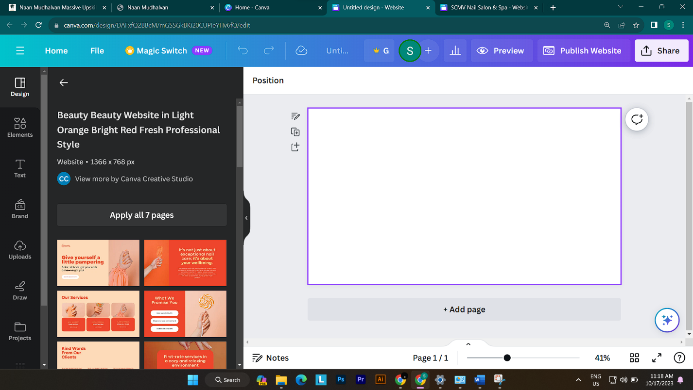

**Step 4: Customize Your Website**

* Use Canva's user-friendly drag-and-drop editor to personalize the template.
* Replace sample text with your brand's information and add images related to your beauty products.
* Adjust fonts, colors, and layout to match your brand's style.

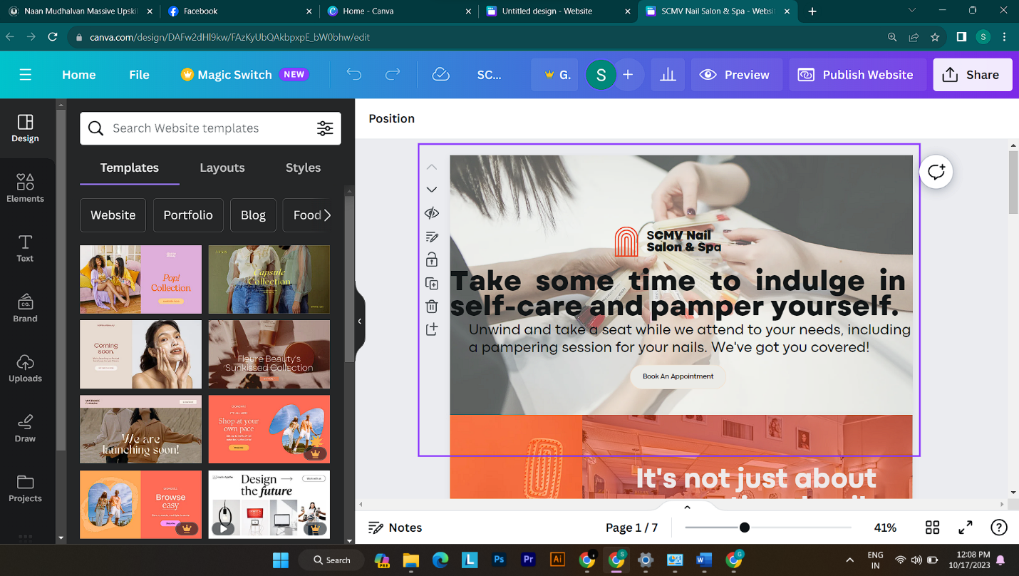

**Step 5: Mobile Optimization**

* Use Canva's responsive design features to ensure your website looks great on both desktop and mobile devices.

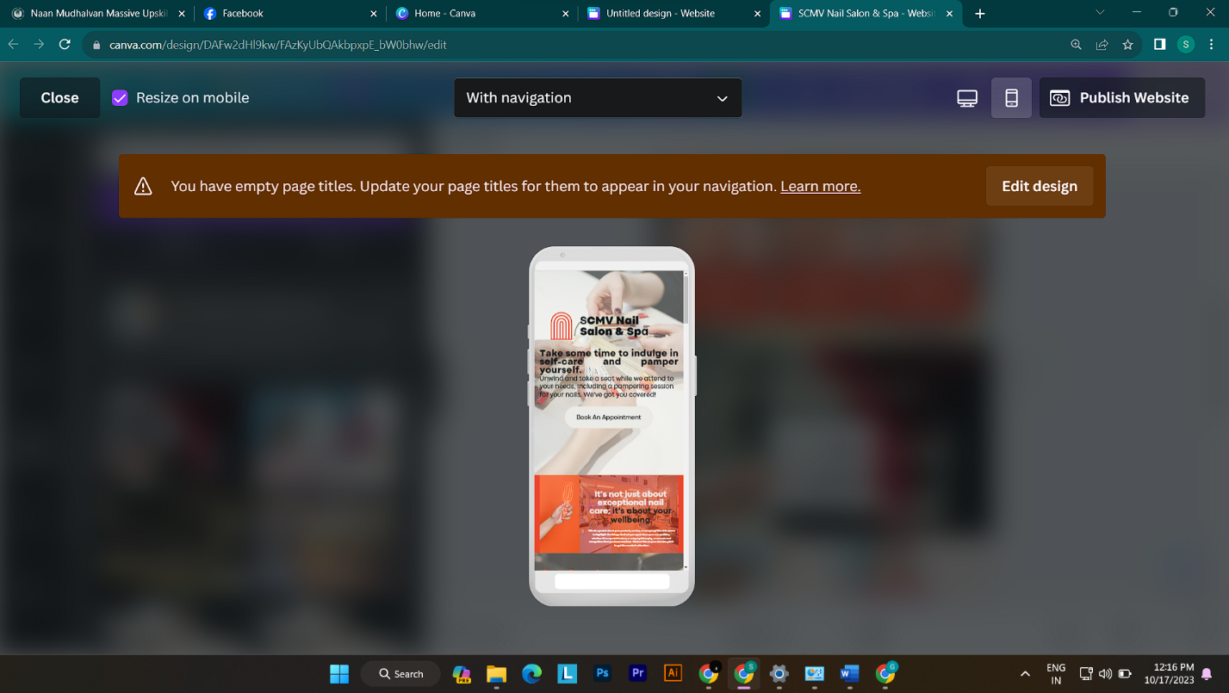

**Step 6: SEO Optimization**

* Improve your website's visibility by adding relevant keywords, meta tags, and descriptions.
* Optimize your content for search engines.

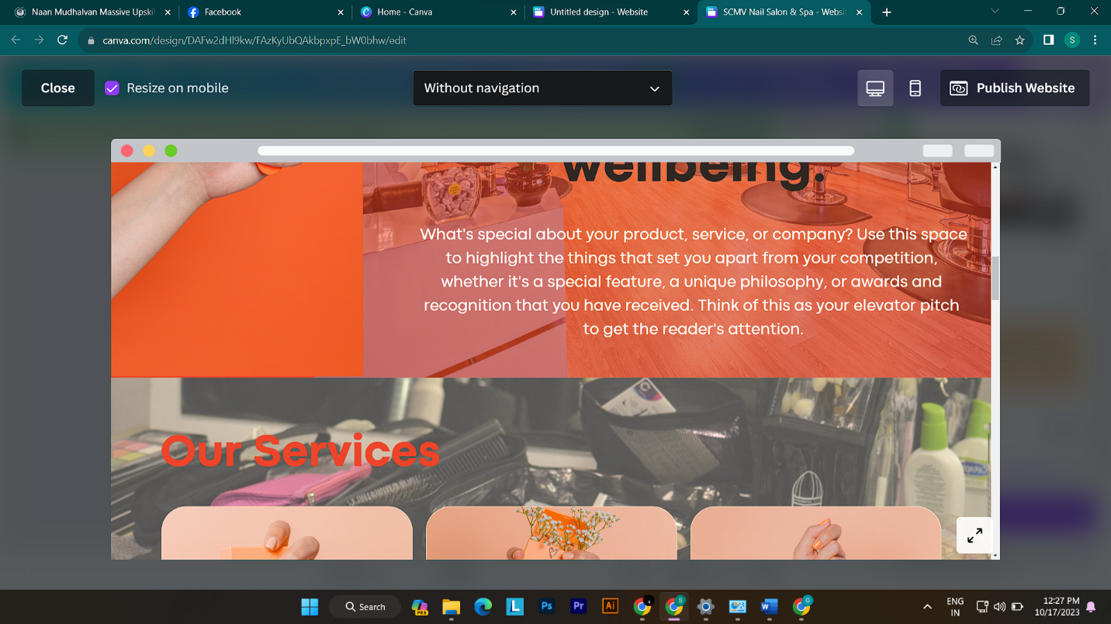

**Step 7: Preview and Test**

* Before publishing, preview your website to check for errors or inconsistencies.
* Test its functionality on various web browsers and devices.

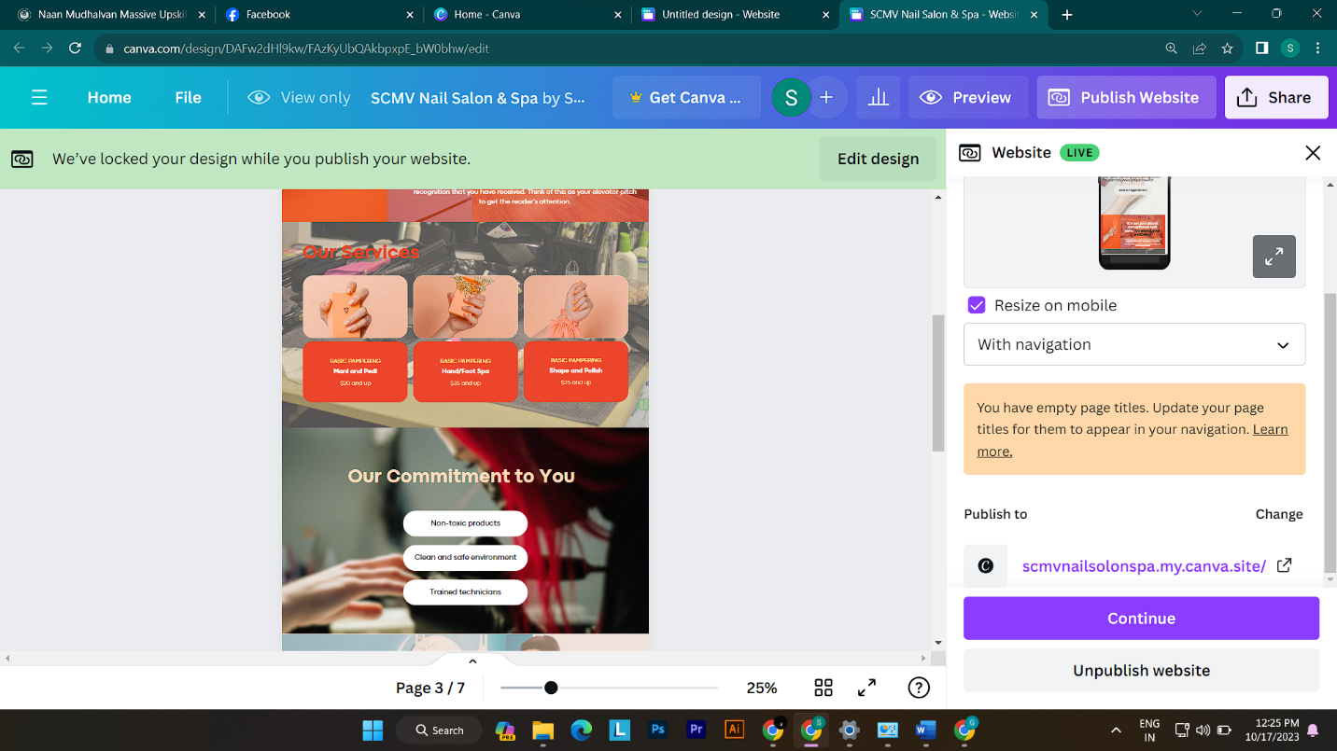

**Step 8: Publish Your Website**

* Once satisfied, click the "Publish" button within Canva to make your website live on the internet.
* Canva may provide options for custom domains or hosting.

https://scmvnailsolonspa.my.canva.site/

* 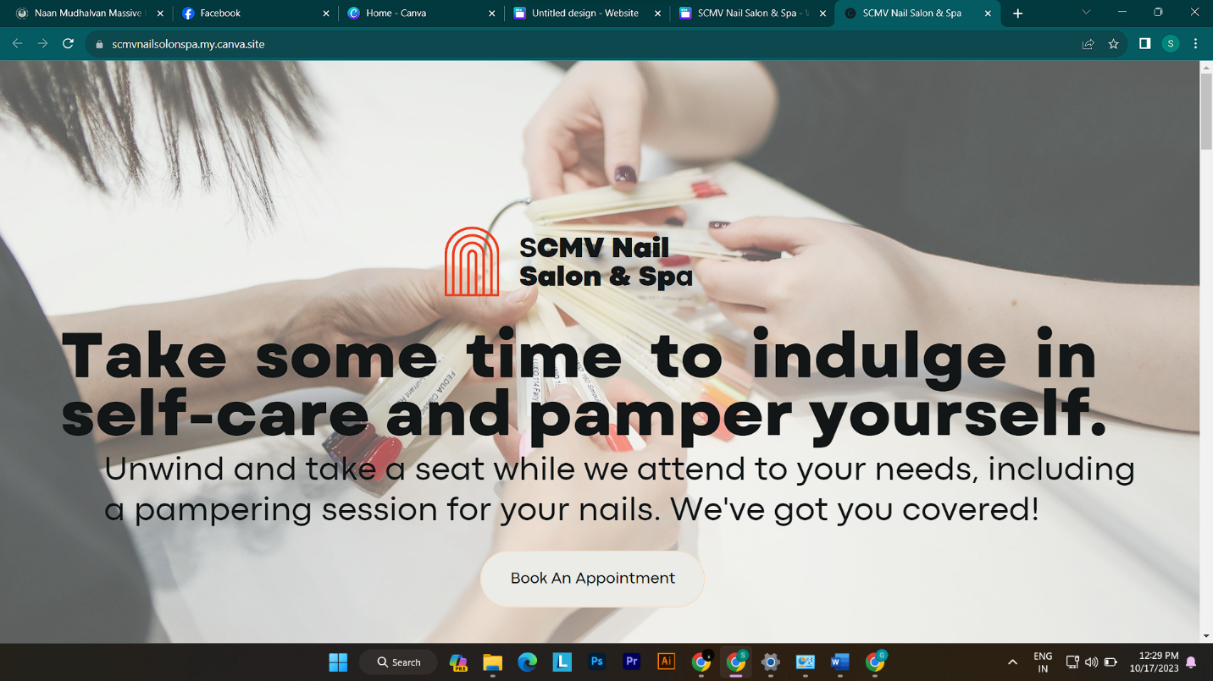

**Step 9 : Upload your Recorded Video**

If you have recorded a video while building your website using Canva, please upload it to share your experience and insights with others.

RECORDED VIDEO LINK

<https://drive.google.com/file/d/1oWHAgg68u9_7eIhj8dd0FAtuo-64gsE7/view?usp=sharing>

CANVA PUBLISHED WEBSITE LINK

<https://scmvnailsolonspa.my.canva.site>

GITHUB LINK